September 6, 2026

MC Craig
Song Leader Ladies
Pianist Barb
Sermon Josh Stobbe

Create in me a pure heart, O God, and renew a steadfast spirit within me. Psalm 51:10 NIV

Divine Instruction – Art Exhibit by David Thiessen
at the Peace Gallery North Sept 5-25 – 11 am to 5 pm
open Tuesdays to Saturdays
Explore David Thiessen’s artistic interpretation of biblical teachings, themes and values through detailed and thought-provoking paintings.

The EFC of Canada Canadian Pacific District
Pastor & Spouse Huddle Oct 1 and District Conference Oct 2-4
Registration required by Sept 10. Talk to Craig or Brad

Sunday School begins Sept 27
Potluck on Sept 27

Saturdays 10 am Men’s Bible Study & Prayer at the church
Sundays 11 am Worship Service

Family of the Week
Craig, Niki, Brynna, Josiah, Tyson, Tarren Luney

*** Prayer Requests***

Pray for Mark Thompson preparing a sermon
for next Sunday

Pastor Search
Pray for our search committee – Brad, Mark and Josh
Pray for a pastor for our congregation

MINISTRY
Outreach Ministry through individual witness
Prodigals
Senior Complex Planning and Fund Raising
Summer Camps – Staff and campers

HEALTH
Craig’s Grandma Luney – in hospital with broken hip and lung infection
Alvina Van Der Merwe – Broke 3 bones in wrist
Freya Thompson - recovering from facial surgery
Josh Thompson – healing of broken leg
Brad Tanner – Cancer treatment in Prince George-has an infection
Sigrid Tobler – health issues
Henry Tobler – recovering from surgery
Mary Fletcher – non-verbal, wheelchair bound, in great pain
Scott’s nephew’s son (Shephard) – cancer care
John & Grace Marshall – John’s MRI RESULTS-no kidney damage
John & Jan Stevenson – John is mostly in a wheel chair
Elvern & Kathy Esau
Jerry & Rose Hale
Thor & Ruth Skafte

Let Barb Thiessen know of announcements and updates.
Text 250 261-4903 or Phone 250 781-3470
Restore to me the joy of your salvation
and grant me a willing spirit, to sustain me.
Psalm 51:12 NIV

________________________________________________________________________________________________________________________________________________________________________________________________________________________________________________________________________________________________________________________________________________________________________________________________________________________________________________________________________________________________________________________________________________________________________________________________________________________________

The email for E-transfer is efcofgoodlow@outlook.com

Evangelical Free Church
of Goodlow

September 6, 2026

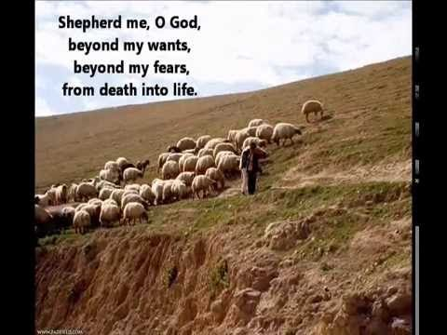
The Lord is my shepherd, I shall not want. Psalm 23:1 NIV

Contact - Brad Giesbrecht
Cell Phone: 250-261-3289
Website: goodlowchurch.ca

Read God’s Word
Study God’s Word
Live God’s Word

