July 5, 2026

MC Scott
Song Leader Michael
Pianist Rachelle
Sermon Brad Giesbrecht
Romans 1:18-32 and Psalm 19
God is angry with our sin!

The heavens proclaim the glory of God.
The skies display his craftsmanship.
Day after day they continue to speak;
night after night they make him known.
They speak without a sound or word;
their voice is never heard.
Yet their message has gone throughout the earth,
and their words to all the world.
Psalm 19:1-4 NLT

But God shows his anger from heaven against all sinful, wicked people who suppress the truth by their wickedness. They know the truth about God because he has made it obvious to them.
Romans 1:18 NLT

Saturdays 10 am Men’s Bible Study & Prayer at the church
Sundays 11 am Worship Service

Happy Birthday
Des Van Der Merwe – July 5

Happy Anniversary
Myron & Linda Esau – July 10

Family of the Week
Fritz & Sarah Bueckert

*** Prayer Requests***

Pray for Scott Willms preparing a sermon
for next Sunday

Pastor Search
Pray for our search committee – Brad, Mark and Josh
Pray for a pastor for our congregation

MINISTRY
Outreach Ministry through individual witness
Prodigals
Senior Complex Planning and Fund Raising
Summer Camps – Staff and campers
Counselling, teaching and safety

HEALTH
Josh Thompson – healing of broken leg
Brad Tanner – cancer
Cheyenne – health problems
Sigrid Tobler – health issues
Mary Fletcher – non-verbal, wheelchair bound, in great pain
Scott’s nephew’s son (Shephard) – cancer care
John & Grace Marshall – Out of hospital-waiting for MRI. Suffering from chills, back pain and has fever off and on. Kidney numbers are low.
John & Jan Stevenson – John is mostly in a wheel chair
Elvern & Kathy Esau
Jerry & Rose Hale
Thor & Ruth Skafte

Let Barb Thiessen know of announcements and updates.
Text 250 261-4903 or Phone 250 781-3470

God overlooked people’s ignorance
about these things in earlier times,
but now he commands everyone everywhere
to repent of their sins and turn to him.
Acts 17:30 NLT

________________________________________________________________________________________________________________________________________________________________________________________________________________________________________________________________________________________________________________________________________________________________________________________________________________________________________________________________________________________________________________________________________________________________________________________________________________________________

The email for E-transfer is efcofgoodlow@outlook.com

Evangelical Free Church
of Goodlow

July 5, 2026

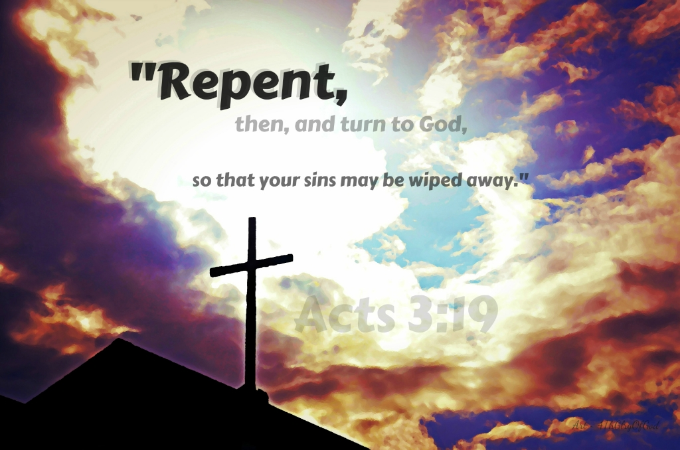

Contact - Brad Giesbrecht
Cell Phone: 250-261-3289
Website: goodlowchurch.ca

Read God’s Word
Study God’s Word
Live God’s Word

