June 14, 2026

MC Michael
Song Leader Craig
Sermon Josh Stobbe

You do not desire a sacrifice, or I would offer one.
You do not want a burnt offering.
The sacrifice you desire is a broken spirit.
You will not reject a broken and repentant heart, O God.
Psalm 51:16-17 NLT

Saturdays 10 am Men’s Bible Study & Prayer at the church
Sundays 11 am Worship Service

Welcome Party for Jane Ella Rempel -This Tuesday – June 16,
At Terry & Agnes Rempel’s place
Potluck Supper BBQ at 6:00 PM
For the whole family – This will be outside

Happy Birthday
Craig Luney – June 14
Halley Esau – June 19

Happy Anniversary
Elvern & Kathy Esau – June 14

Family of the Week
Chelsea Willms
*** Prayer Requests***

Pray for Mark Thompson preparing a sermon
for next Sunday

Pastor Search
Pray for our search committee – Brad, Mark and Josh
Pray for a pastor for our congregation

MINISTRY
Outreach Ministry through individual witness
Prodigals
Senior Complex Planning and Fund Raising
Summer Camps – Fund Raising and staff recruitment
Safety of staff and campers

HEALTH
Josh Thompson – healing of broken leg
Brad Tanner – health issues
Cheyenne – assessment and possible surgery
Sigrid Tobler – health issues
Mary Fletcher – non-verbal, wheelchair bound, in great pain
Scott’s nephew’s son (Shephard) – cancer care
John & Jan Stevenson
Elvern & Kathy Esau
Jerry & Rose Hale – Jerry has stage 4 cancer
Thor & Ruth Skafte

Let Barb Thiessen know of announcements and updates.
Text 250 261-4903 or Phone 250 781-3470

No, O people, the Lord has told you what is good,
and this is what he requires of you:
to do what is right,
to love mercy,
and to walk humbly with your God.
Micah 6:8 NLT

________________________________________________________________________________________________________________________________________________________________________________________________________________________________________________________________________________________________________________________________________________________________________________________________________________________________________________________________________________________________________________________________________________________________________________________________________________________________

The email for E-transfer is efcofgoodlow@outlook.com
Evangelical Free Church
of Goodlow

June 14, 2026

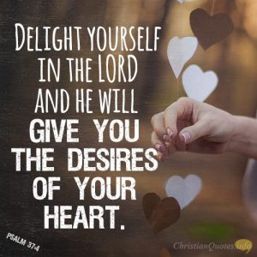
Psalm 37:4

Contact - Brad Giesbrecht
Cell Phone: 250-261-3289
Website: goodlowchurch.ca

Read God’s Word
Study God’s Word
Live God’s Word

