April 5, 2026

Song Leader Michael
Pianist Rachelle
MC Mark
Sermon Josh Stobbe

Then the men asked, “Why are you looking among the dead for someone who is alive? He isn’t here! He is risen from the dead! Remember what he told you back in Galilee, that the Son of Man must be betrayed into the hands of sinful men and be crucified, and that he would rise again on the third day.”
Luke 24:5b-7 NLT

Saturdays 10 am Men’s Bible Study & Prayer at the-church
Sundays 10 am Sunday School for all ages
11 am Worship Service
Tuesdays 6:30 pm AWANA at Cecil Lake Church
Fridays - 7 pm Youth Group at the church

Happy Birthday Happy Anniversary
Terry Rempel – April 7 Brad & Elaine Giesbrecht – April 6
Dale Fell – April 8

Family of the Week
John & Jan Stevenson

*** Prayer Requests***

Pray for Michael Clark preparing a sermon
for next Sunday

Pastor Search
Pray for our search committee – Brad, Mark and Josh
Pray for a pastor for our congregation

MINISTRY
Outreach Ministry through individual witness
Prodigals
Senior Complex Planning and Fund Raising
Sunday School Teachers
AWANA leaders
Summer Camps – Fund Raising and staff recruitment

HEALTH
Walter Enns – Recovery from open heart surgery
Sigrid Tobler – health issues
Mary Fletcher – non-verbal, wheelchair bound, in great pain
Michael Bueckert – healing from burns
Fred Klassen – Stroke/cancer recovery
Scott’s nephew’s son (Shephard) – cancer care
John & Jan Stevenson
Elvern & Kathy Esau
Jerry & Rose Hale – Jerry has stage 4 cancer
Thor & Ruth Skafte

Let Barb Thiessen know of announcements and updates.
Text 250 261-4903 or Phone 250 781-3470

“People of Israel, listen! God publicly endorsed Jesus the Nazarene by doing powerful miracles, wonders and signs through him, as you well know. But God knew what would happen, and his prearranged plan was carried out when Jesus was betrayed. With the help of lawless Gentiles, you nailed him to a cross and killed him. But God released him from the horrors of death and raised him back to life, for death could not keep him in its grip.”
Acts 2:22-24 NLT

________________________________________________________________________________________________________________________________________________________________________________________________________________________________________________________________________________________________________________________________________________________________________________________________________________________________________________________________________________________________________________________________________________________________________________________________________________________________

The email for E-transfer is efcofgoodlow@outlook.com

Evangelical Free Church
of Goodlow

April 5, 2026

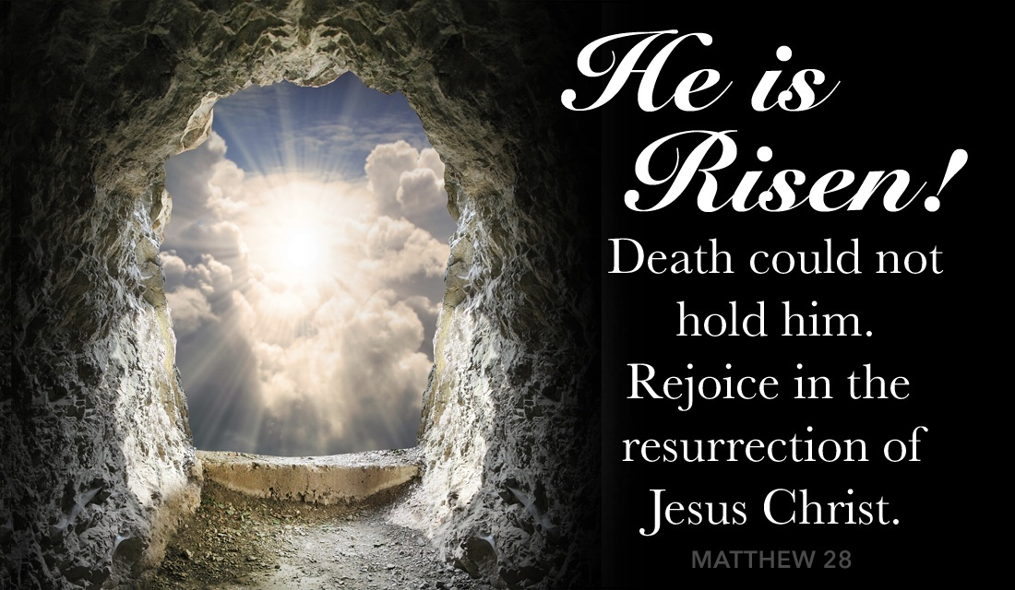

Contact - Brad Giesbrecht
Cell Phone: 250-261-3289
Website: goodlowchurch.ca

Read God’s Word
Study God’s Word
Live God’s Word

