April 26, 2026

Song Leader Ladies
Pianist Barb
MC Nathan
Sermon Michael Giesbrecht

God has united us with Christ Jesus. For our benefit God made him to be wisdom itself. Christ made us right with God; he made us pure and holy, and he freed us from sin. Therefore, as the Scriptures say, “If you want to boast, boast only about the Lord”.
1 Corinthians 1:30-31 NLT

Saturdays 10 am Men’s Bible Study & Prayer at the-church
Sundays 10 am Sunday School for all ages
11 am Worship Service
Tuesdays 6:30 pm AWANA at Cecil Lake Church
Fridays - 7 pm Youth Group at the church

May 2 – WorkBee at Camp Sagitawa, Moberly Lake.
For details talk to Melanie

May 3 –NEXT SUNDAY POTLUCK after the morning service

Happy Anniversary
Marty & Mel Harmon – April 28

Family of the Week
David & Barb Thiessen
*** Prayer Requests***

Pray for Josh Stobbe preparing a sermon
for next Sunday

Pastor Search
Pray for our search committee – Brad, Mark and Josh
Pray for a pastor for our congregation

MINISTRY
Outreach Ministry through individual witness
Prodigals
Senior Complex Planning and Fund Raising
Sunday School Teachers
AWANA leaders
Summer Camps – Fund Raising and staff recruitment

HEALTH
Percy Gould – heart issues,
Walter Enns – Recovery from open heart surgery
Sigrid Tobler – health issues
Mary Fletcher – non-verbal, wheelchair bound, in great pain
Michael Bueckert – healing from burns
Fred Klassen – Stroke/cancer recovery
Scott’s nephew’s son (Shephard) – cancer care
John & Jan Stevenson
Elvern & Kathy Esau
Jerry & Rose Hale – Jerry has stage 4 cancer
Thor & Ruth Skafte

Let Barb Thiessen know of announcements and updates.
Text 250 261-4903 or Phone 250 781-3470

Why are you so frightened? Why are your hearts filled with doubt? Look at my hands. Look at my feet. You can see that it’s really me. Touch me and make sure that I am not a ghost…
Luke 24:38-40a NLT

________________________________________________________________________________________________________________________________________________________________________________________________________________________________________________________________________________________________________________________________________________________________________________________________________________________________________________________________________________________________________________________________________________________________________________________________________________________________

The email for E-transfer is efcofgoodlow@outlook.com

Evangelical Free Church
of Goodlow

April 26, 2026

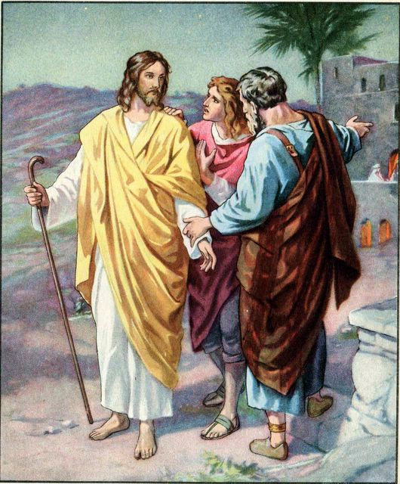
Jesus explained all the Scriptures concerning himself

Contact - Brad Giesbrecht
Cell Phone: 250-261-3289
Website: goodlowchurch.ca

Read God’s Word
Study God’s Word
Live God’s Word

