April 12, 2026

Song Leader Ron
Pianist Charlotte
MC Scott
Sermon Michael Clark
Colossians 1:1-13

So do not throw away this confident trust in the Lord.
Remember the great reward it brings you!
Patient endurance is what you need now,
so that you will continue to do God’s will. Then you will receive all that he has promised.
Hebrews 10:35-36 NLT

Small as a seed (Lk 17:6)
Soft as a prayer (1 Thess 5:17)
Faith grows strongest
When placed in His care. (Heb 12:2)

Saturdays 10 am Men’s Bible Study & Prayer at the-church
Sundays 10 am Sunday School for all ages
11 am Worship Service
Tuesdays 6:30 pm AWANA at Cecil Lake Church
Fridays - 7 pm Youth Group at the church

Happy Anniversary
Craig & Niki Luney – April 13

Family of the Week
Nathan Stevenson

*** Prayer Requests***

Pray for Scott Willms preparing a sermon
for next Sunday

Pastor Search
Pray for our search committee – Brad, Mark and Josh
Pray for a pastor for our congregation

MINISTRY
Outreach Ministry through individual witness
Prodigals
Senior Complex Planning and Fund Raising
Sunday School Teachers
AWANA leaders
Summer Camps – Fund Raising and staff recruitment

HEALTH
Percy Gould – heart issues, in Edmonton
Walter Enns – Recovery from open heart surgery
Sigrid Tobler – health issues
Mary Fletcher – non-verbal, wheelchair bound, in great pain
Michael Bueckert – healing from burns
Fred Klassen – Stroke/cancer recovery
Scott’s nephew’s son (Shephard) – cancer care
John & Jan Stevenson
Elvern & Kathy Esau
Jerry & Rose Hale – Jerry has stage 4 cancer
Thor & Ruth Skafte

Let Barb Thiessen know of announcements and updates.
Text 250 261-4903 or Phone 250 781-3470

Let your conversation be gracious and attractive
so that you will have the right response for everyone.
Colossians 4:6 NLT

________________________________________________________________________________________________________________________________________________________________________________________________________________________________________________________________________________________________________________________________________________________________________________________________________________________________________________________________________________________________________________________________________________________________________________________________________________________________

The email for E-transfer is efcofgoodlow@outlook.com

Evangelical Free Church
of Goodlow

April 12, 2026

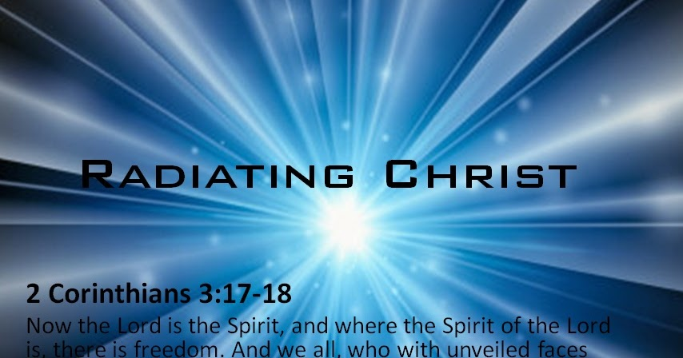
Reflect the glory of the Lord …
the Lord makes us more and more like Him.

Contact - Brad Giesbrecht
Cell Phone: 250-261-3289
Website: goodlowchurch.ca

Read God’s Word
Study God’s Word
Live God’s Word

