March 8, 2026

Song Leader Ladies
Pianist Barb
MC Michael
Sermon Jet Takaoka

He (God) made heaven and earth,
the sea, and everything in them.
He keeps every promise forever.
Psalm 146:6 NLT

Saturdays 10 am Men’s Bible Study & Prayer at the-church
Sundays 10 am Sunday School for all ages
11 am Worship Service
Tuesdays 6:30 pm Awana at Cecil Lake Church
Fridays - 7 pm Youth Group at the church

TODAY– Soup & Sandwich POTLUCK

April 3 – Good Friday Service at Cecil Lake Church

Happy Birthday
Sam Roberts – March 11
Charlotte Rempel – March 13
Ben Bueckert – March 13

Family of the Week
Ron, Charlotte, Amanda, Erin Rempel

*** Prayer Requests***

Pray for Michael Giesbrecht preparing a sermon
for next Sunday

Pastor Search
Pray for our search committee – Brad, Mark and Josh
Pray for a pastor for our congregation

MINISTRY
Outreach Ministry through individual witness
Prodigals
Senior Complex Planning and Fund Raising
Sunday School Teachers
AWANA leaders
Summer Camps – Fund Raising and staff recruitment

HEALTH
Walter & Dolores Enns – Walter had open heart surgery
Cheyenne Kvikstad-daughter of Hannah Harmon/Clayton Kvikstad-in Vancouver for surgery
Sigrid Tobler – KNEE replacement recovery
Mary Fletcher – non-verbal, wheelchair bound, in great pain
Michael Bueckert – healing from burns
Fred Klassen – Stroke/cancer recovery
Scott’s nephew’s son (Shephard) – cancer care
John & Jan Stevenson
Elvern & Kathy Esau
Jerry & Rose Hale – Jerry has stage 4 cancer
Thor & Ruth Skafte

BEREAVEMENT
Terry Piper passed away on Thursday. Pray for the family.

Let Barb Thiessen know of announcements and updates.
Text 250 261-4903 or Phone 250 781-3470

Now you have every spiritual gift you need
as you eagerly wait for the return of our Lord Jesus Christ.
He will keep you strong to the end
so that you will be free from all blame
on the day when our Lord Jesus Christ returns.
God will do this, for he is faithful to do what he says,
and he has invited you
into partnership with his Son, Jesus Christ our Lord.
1 Corinthians 1:7-9 NLT

________________________________________________________________________________________________________________________________________________________________________________________________________________________________________________________________________________________________________________________________________________________________________________________________________________________________________________________________________________________________________________________________________________________________________________________________________________________________

The email for E-transfer is efcofgoodlow@outlook.com

Evangelical Free Church
of Goodlow

March 8, 2026

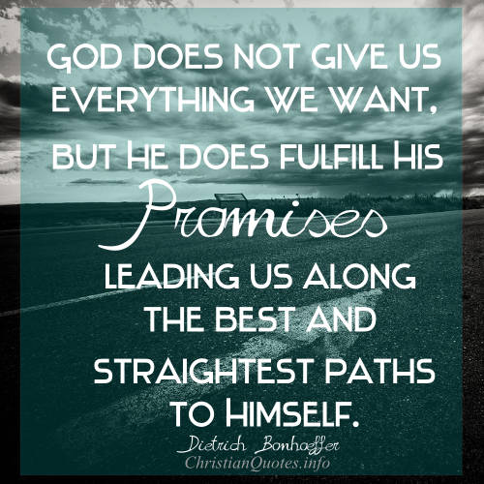

Contact - Brad Giesbrecht
Cell Phone: 250-261-3289
Website: goodlowchurch.ca

Read God’s Word
Study God’s Word
Live God’s Word

