March 1, 2026

Song Leader Craig
MC Josh
Sermon Brad Giesbrecht
Defend the Faith

But now I find that I must write about something else; urging you to defend the faith that God has entrusted once for all time to his holy people. Because some ungodly people have wormed their way into your churches…Jude 3, 4 NLT

Saturdays 10 am Men’s Bible Study & Prayer at the-church
Sundays 10 am Sunday School for all ages
11 am Worship Service
Tuesdays 6:30 pm Awana at Cecil Lake Church
Fridays - 7 pm Youth Group at the church

March 6-7 - Mission Vision – North Peace MB FSJ
They would like us to give 10 dozen cookies and 2 dozen muffins for the weekend. NO NUTS. Contact Margaret with questions-250-793-1868
Elaine will store the baking for this event.

March 8 – Jet Takaoka, with Canadian Foodgrains Bank, will be speaking. Soup & Sandwich POTLUCK to follow.

April 3 – Good Friday Service at Cecil Lake Church

Happy Birthday Family of the Week Agnes Rempel – March 1 Craig, Niki, Brynna, Josiah, Tyson Luney

Happy Anniversary
Jeff & Alicia Enns – March 3
Ken & Karen Ott – March 6
*** Prayer Requests***

Pray for Jet Takaoka preparing a sermon
for next Sunday

Pastor Search
Pray for our search committee – Brad, Mark and Josh
Pray for a pastor for our congregation

MINISTRY
Outreach Ministry through individual witness
Prodigals
Senior Complex Planning and Fund Raising
Sunday School Teachers
AWANA leaders

HEALTH
Walter & Dolores Enns – Walter will have open heart surgery on Tuesday March 3, in Vancouver
Freyja Thompson – Mark & Diane’s granddaughter-is off pain meds
Cheyenne Kvikstad-daughter of Hannah Harmon/Clayton Kvikstad-in Vancouver for surgery
Sigrid Tobler – KNEE replacement recovery
Mary Fletcher – non-verbal, wheelchair bound, in great pain
Michael Bueckert – healing from burns
Fred Klassen – Stroke/cancer recovery
Scott’s nephew’s son (Shephard) – cancer care
John & Jan Stevenson
Elvern & Kathy Esau
Jerry & Rose Hale – Jerry has stage 4 cancer
Thor & Ruth Skafte

Pray for the people of Tumbler Ridge in the aftermath of the killing of several people there plus the healing of the many that were injured

Let Barb Thiessen know of announcements and updates.
Text 250 261-4903 or Phone 250 781-3470
To learn, you must love discipline;
It is stupid to hate correction.
Proverbs 12:1 NLT

________________________________________________________________________________________________________________________________________________________________________________________________________________________________________________________________________________________________________________________________________________________________________________________________________________________________________________________________________________________________________________________________________________________________________________________________________________________________

The email for E-transfer is efcofgoodlow@outlook.com

Evangelical Free Church
of Goodlow

March 1, 2026

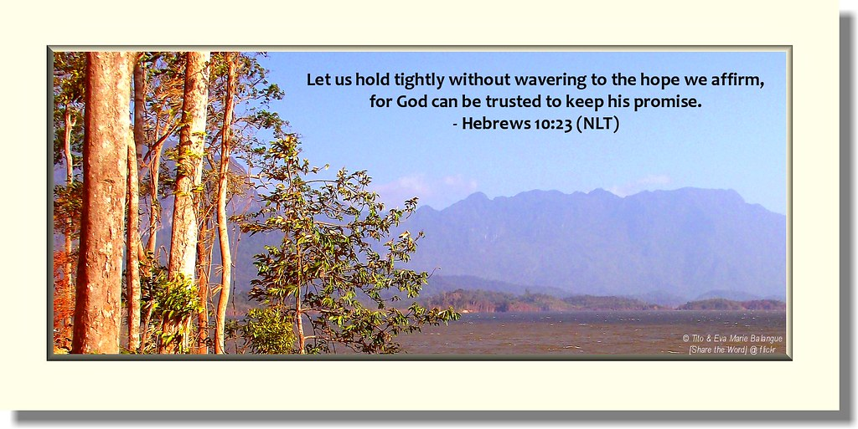

Contact - Brad Giesbrecht
Cell Phone: 250-261-3289
Website: goodlowchurch.ca

Read God’s Word
Study God’s Word
Live God’s Word

