February 8, 2026

Song Leader Michael
MC Brad
Sermon Josh Stobbe

You were his enemies,
separated from him by your evil thoughts and actions.
Yet now he has reconciled you to himself
through the death of Christ in his physical body.
As a result, he has brought you into his own presence,
and you are holy and blameless as you stand before him without a single fault.
But you must continue to believe this truth and stand firmly in it.
Colossians 1:21-23a NLT

Saturdays 10 am Men’s Bible Study & Prayer at the-church
Sundays 10 am Sunday School for all ages
11 am Worship Service
Tuesdays 6:30 pm Awana at Cecil Lake Church
Fridays - 7 pm Youth Group at the church

Feb 26 – AGM – 7 pm at church

March 6-7 - Mission Vision – North Peace MB FSJ
They would like us to give 10 dozen cookies and 2 dozen muffins for the weekend. Contact Margaret with questions-250-793-1868

Happy Birthday Family of the Week Diane Thompson – Feb 8 Brad & Elaine Giesbrecht
Calvin Rempel – Feb 12
Brynna Luney – Feb 15

*** Prayer Requests***

Pray for Mark Thompson preparing a sermon
for next Sunday

Pastor Search
Pray for our search committee – Brad, Mark and Josh
Pray for a pastor for our congregation

MINISTRY
Outreach Ministry through individual witness
Prodigals
Senior Complex Planning and Fund Raising
Sunday School Teachers
AWANA leaders

HEALTH
Mary Fletcher – non-verbal, wheelchair bound, in great pain
Michael Bueckert – healing from burns
Fred Klassen – Stroke/cancer recovery-check up in Vancouver resulted in no new tumor growth – At home working on rehabilitation – Fred is starting to use a walker- confesses to learning lots of patience
Scott’s nephew’s son (Shephard) – cancer care
Sigrid Tobler – healing of back pain, healing from cancer
John & Jan Stevenson
Elvern & Kathy Esau
Jerry & Rose Hale – Jerry has stage 4 cancer
Thor & Ruth Skafte

Let Barb Thiessen know of announcements and updates.
Text 250 261-4903 or Phone 250 781-3470

Live wisely among those who are not believers,
and make the most of every opportunity.
Colossians 4:5 NLT

________________________________________________________________________________________________________________________________________________________________________________________________________________________________________________________________________________________________________________________________________________________________________________________________________________________________________________________________________________________________________________________________________________________________________________________________________________________________

The email for E-transfer is efcofgoodlow@outlook.com

Evangelical Free Church
of Goodlow

February 8, 2026

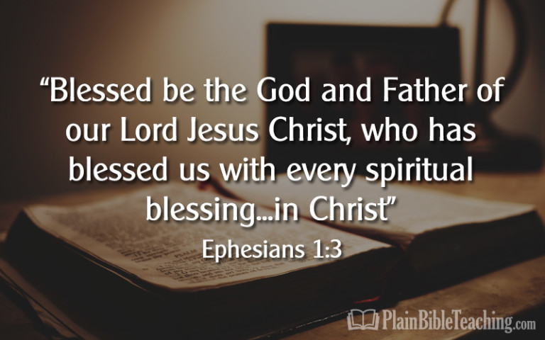

Contact - Brad Giesbrecht
Cell Phone: 250-261-3289
Website: goodlowchurch.ca

Read God’s Word
Study God’s Word
Live God’s Word

