January 11, 2026

Song Leader Ladies
Pianist Barb
MC Scott
Sermon Craig Luney

Come, let us worship and bow down.
Let us kneel before the Lord our Maker.
Psalm 95:6 NASB

Saturdays 10 am Men’s Bible Study & Prayer at the-church
Sundays 10 am Sunday School for all ages
11 am Worship Service
Tuesdays 6:30 pm Awana at Cecil Lake Church
Fridays - 7 pm Youth Group at the church

Jan 15 - Board Meeting – 7 pm at the church

Happy Birthday
Larry Vander Linden – Jan 11

Family of the Week
Walter & Dolores Enns

*** Prayer Requests***

Pray for Brad Giesbrecht preparing a sermon
for next Sunday

Pastor Search
Pray for our search committee – Brad, Mark and Josh
Pray for a pastor for our congregation

MINISTRY
Outreach Ministry through individual witness
Prodigals
Senior Complex Planning and Fund Raising
Sunday School Teachers
AWANA leaders

HEALTH
Mary Fletcher – non-verbal, wheelchair bound, in great pain
Michael Bueckert – healing from burns
Fred Klassen – Stroke/cancer recovery
Scott’s nephew’s son (Shephard) – cancer care
Sigrid Tobler – healing of back pain, healing from cancer
John & Jan Stevenson
Elvern & Kathy Esau
Jerry & Rose Hale – Jerry has stage 4 cancer
Thor & Ruth Skafte

Let Barb Thiessen know of announcements and updates.
Text 250 261-4903 or Phone 250 781-3470

Exalt the Lord our God.
And worship at His footstool;
Holy is He.
Psalm 99:5 NASB

________________________________________________________________________________________________________________________________________________________________________________________________________________________________________________________________________________________________________________________________________________________________________________________________________________________________________________________________________________________________________________________________________________________________________________________________________________________________

The email for E-transfer is efcofgoodlow@outlook.com

Evangelical Free Church
of Goodlow

January 11, 2026

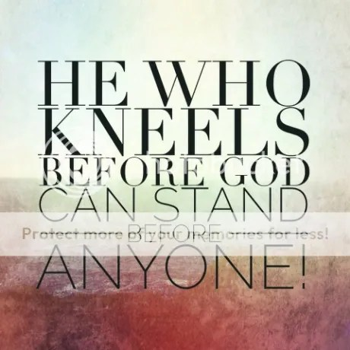

Contact - Brad Giesbrecht
Cell Phone: 250-261-3289
Website: goodlowchurch.ca

Read God’s Word
Study God’s Word
Live God’s Word

